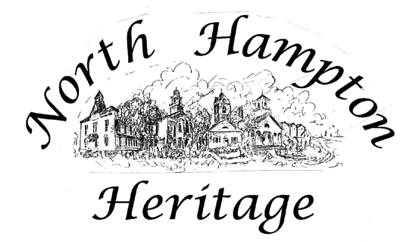

Commission

Master Plan [MP] Sub-committee
19 January 2021
Zoom Call

Sub-committee members Cynthia Swank, Donna Etela, Carol Seely, and Vicki Jones present on Zoom.

Session began at 3:00 pm. The group reviewed the North Hampton Master Plan Chapter Drafting Guide provided by Jenn Rowden from Rockingham Planning Commission. The updated documents were reviewed and possible locations in the new chapter were discussed.

The group discussed the History of North Hampton currently in the Historic Resources section of the Master Plan. It was decided that the history could be moved to the Heritage Commission website and eventually onto PastPerfect with other Heritage Commission photographs and documents.

The Summary of Heritage Commission Activities document will be part of the new section Introduction with the addition of a high level overview of the Commission.

The draft Vision and Goals were reviewed and changes were suggested. Jones will update the drafts for sub-committee review. There was some discussion about the inclusion of cemeteries and archeological sites in the documents.

It was suggested that it would be valuable to have representation from Little Boar’s Head to the Heritage Commission, perhaps as an alternate. Jones has contacted Pat Meyers for suggestions.

The session concluded at 3:40 pm.

Vicki Jones

