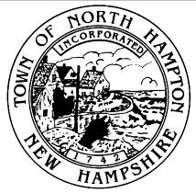
Town of North Hampton, New Hampshire
Joint Loss Management committee
draft minutes
september 19, 2022 1:00PM
Executive conference room

- Call to Order
Chair Hubbard called the meeting to order at 1:07PM. Those in attendance were Jeff Barnes, Joe Manzi, Jared Shaheen, Jason Lajoie, Kathryn Mone and Jan Facella. Absent were Sue Buchanan and Liz Herold.

- New Business
2.1 Approval of Minutes from June 20, 2022
Motion by Kathryn Mone to approve the minutes of June 20, 2022. Seconded by Joe Manzi. Motion carries 7-0.

2.2 General Discussion
Discussion ensued regarding the time line for the new buildings.

Joe Manzi stated the he now had a defibrillator at Dearborn Park and a portable defibrillator at the Recreation Center.

2.3 Any Other Business to Come Before the Committee

- Adjournment
Meeting adjourned at 1:22PM.

Respectfully submitted,
Janet Facella

