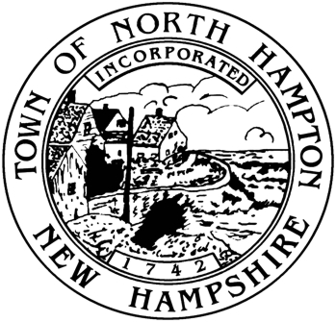
Municipal Offices
233 Atlantic Avenue
North Hampton, NH 03862

Tel: (603) 964-8087
Fax: (603) 964-1514
Jim O’Hara
Recreation Director

johara@northhampton-nh.gov
TEL: (603) 964-3170
Town of North Hampton, New Hampshire
Recreation Department

RECREATION COMMISSION MEETING
Wednesday March 15th, 2016
5:30pm Mary Herbert Room

Agenda:
- Public Comments
- WinterFest Wrap Up
- Comedy Night
- Egg Scramble
- Closing Comments

