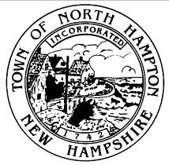
Town of North Hampton, New Hampshire
Joint Loss Management committee
agenda
December 12, 2022 1:00PM
Executive conference room

- Call to Order

- New Business
2.1 Approval of Minutes from September 19, 2022
2.2 General Discussion
2.3 Any Other Business to Come Before the Committee

- Adjournment

